***PAAREES PERFUMES***

***VERSACE***

***FOR UNISEX***

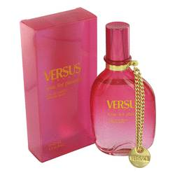

# 

# *Time For Pleasure*

## *Description:*

Time For Pleasure by Versace Perfume. If you are in search of a light and refreshing signature scent for everyday wear, Time For Pleasure exceeds expectations. Prestigious design house Versace created this outstanding fragrance for women in 2003. Its lively, fruity bouquet marries top notes of strawberry, blackberry and blueberry with base notes of nectarine and apricot to produce a tantalizing aroma that helps you make an impact. Time For Pleasure is ideal for daytime wear, so apply some before heading to the office or a lunch date with someone special.